**Practical No.09**

**A] jQuery Animation effects, jQuery Chaining**

**Code:**

<!DOCTYPE html>

<html>

<head>

<meta charset="utf-8">

<title>Example of jQuery Method Chaining</title>

<script src="jquery.js"></script>

<style type="text/css">

p {

width: 200px;

padding: 40px 0;

font: bold 24px sans-serif;

text-align: center;

background: #FFC0CB;

border: 1px solid #87CEFA;

box-sizing: border-box;

}

</style>

<script type="text/javascript">

$(document).ready(function(){

$(".start").click(function(){

$("p")

.animate({width: "100%"})

.animate({fontSize: "46px"})

.animate({borderWidth: 30});

});

$(".reset").click(function(){

$("p").removeAttr("style");

});

});

</script>

</head>

<body>

<p>WELCOME</p>

<button type="button" class="start">Start Chaining</button>

<button type="button" class="reset">Reset</button>

</body>

</html>

**Output:**

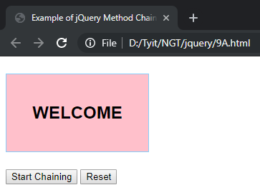

**Click on Start Chaining:**

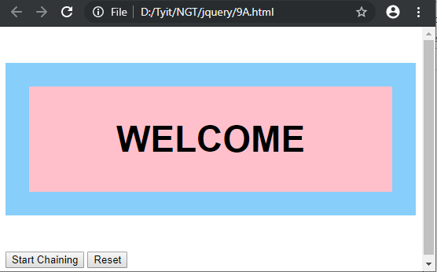

**B] jQuery Callback, jQuery Get and Set Contents**

**Code:**

<!DOCTYPE html>

<html>

<head>

<script src="jquery.js"></script>

</head>

<body>

<script type="text/javascript">

$(document).ready(function(){

$("#b2").click(function(){

alert("Text: " + $("#test").text());

});

$("#b3").click(function(){

alert("html: " + $("#test1").html());

});

$("#b4").click(function(){

alert("value: " + $("#t1").val());

});

$("#b5").click(function(){

alert("attribute: " + $("#t2").attr("id"));

});

});

</script>

<p id="test">NEXT GENERATION TECHNOLOGY: <b>Hello jQuery Advanced</b></p>

<p id="test1">NEXT GENERATION TECHNOLOGY: <b>Bye jQuery Advanced</b></p>

Enter value:<input type="text" id="t1">

Enter Attribute:<input type="text" id="t2">

<br><br>

<button id="b2">text</button>

<button id="b3">html</button>

<button id="b4">value</button>

<button id="b5">attribute</button>

</body>

</html>

**Output:**

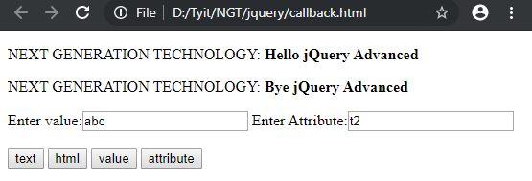

**Click on text button: Click on html button:**

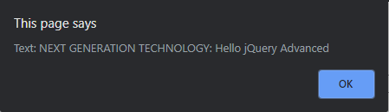 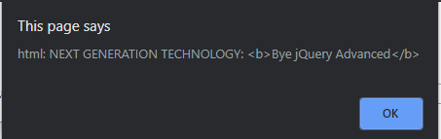

**Click on value button: Click on Attribute button:**

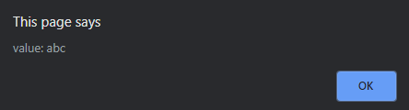 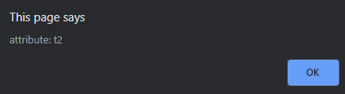

**C] jQuery Insert Content, jQuery Remove Elements and Attribute**

**Code:**

<!DOCTYPE html>

<html>

<head>

<script src="jquery.js"></script>

</head>

<body>

<script type="text/javascript">

$(document).ready(function(){

$("#b1").click(function(){

$("ul").append("<b>NGT</b>")

})/li

$("#b2").click(function(){

$("ul").remove()

alert("Remove successfully!!")

})

$("#b3").click(function(){

$("ul").prepend("<b>SEM-5!!</b>")

})

});

</script>

<ul>

<li>AI</li>

<li>IOT</li>

<li>AWP</li>

<li>SPM</li>

</ul>

<button id="b1">append</button>

<button id="b2">Remove</button>

<button id="b3">prepend</button>

</body>

</html>

**Output:**

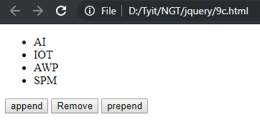

**Append: Prepend:**

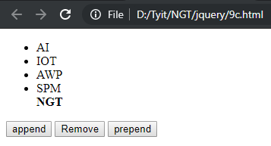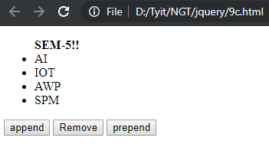

**Remove:**

